**OUTLINE Pilot 1: Soil maturation and MeJA concentration, version 10/27/2020**

**Pedro Beschoren da Costa, Marcela Aragón, Zulema Carracedo**

This pilot has 2 goals, the first one is to check the effects of soil maturation in seedling germination (Pedro, folder Pilot 1: Soil maturation) and the second one is to determine which concentration of MeJA is best to use for Family experiment.

**MeJA concentration**

The current plan for the family experiment is to use one concentration of MeJA for >25 species of Brassicaceae, ideally 100uM (Hickman et al., 2017; Berendsen et al., 2018). However whether this concentration will elicit a similar JA-response in different plant species remains unknown. Furthermore, the method of MeJA dipping in Silwet is also new and practise is required before the big experiment. For this reason, 2 concentrations of MeJA and insect oral secretion as a biological control will be tested in 2 species; *Arabidopsis thaliana* (Lineage 1) and *Brassica oleraceae* (Lineage 2) to measure gene expression of JA-responsive genes (*MYC2* and *LOX2*).

It was decided to use oral secretion of caterpillars instead of real herbivory as it is easier to control for an homogeneous stress application for both plant species, this is a common method used in literature and it will serve as reference for plant gene expression in response to chewing-bitting herbivory stress.

**Treatments(4):**

1. Mock control (Silwet L77 0.015% + EtOH 0.1%?)
2. MeJA 100uM + Silwet L77 0.015%
3. MeJA XXXuM + Silwet L77 0.015%
4. *P. brassicae* oral secretion (OS) + Silwet L77 0.015%*[1]

**Plant species(2):**

1. Arabidopsis thaliana Col-0
2. Brassica oleraceae cvar Riviera

**Evaluations:**

1. Seedling germination efficiency (%)
2. Seedling lenght before transplantation (7das)
3. Time to phenological stages from sowing until end of experiment
4. Gene expression of LOX2 and MYC2
5. Non-destructive plant traits (number of leaves, WxL of second expanded leaf, ??)
6. Root and Shoot biomass

**Treatment combinations and replicates:**

Replicates per treatment/species= 6  
4*2=8*6= 48 plants in total, 24 for each species

**Time lenght**

|  |  |  |
| --- | --- | --- |
| **Step** | **Time** | **Date start** |
| Seed stratification | 2 days | 21/10 |
| Seedling growth | 7 days | 23/10 |
| Transplant and growth | 9 days | 30/10 |
| Treatments application (4x) | 8 days | 09/11 |
| Sampling for q-PCR | 1 day | 16/11 |
| Plant harvest | 1 day | 18/11 |
| q-PCR | 1 week | 23/11 |
| Data analysis | 1 week | 23/11 |

**Overall protocol**

* Seeds of both species were stratified at 4C in a Petri dish with a moist filter paper for 2 days (21/10->23/10).
* Seeds were sown in non-conditioned soil (full seedling tray with 700ml of water) and soil conditioned for 2 weeks in climate cell. 44 seeds were sown (23/10) per species in each of the trays (88 seeds/species in total).
* Germination was checked 3 days later and trays were watered (26/10). Watering will take place every other day.
* 7 days after sowing, seedling lenght will be measured and transplant to 1L conditioned-pots will take place (30/10).
* After transplant plants will be left to grow for 10 days after which MeJA application will start (09/11).
* MeJA + Silwet will be applied every 2 days, during 8 days for a total of 4 applications.
* <24 hours after last MeJA/OS application leaf discs will be collected for gene expression analysis

**OUTLINE Pilot 1: Soil maturation and sterilization of seeds**

**Pedro Beschoren da Costa, Marcela Aragón, Zulema Carracedo**

**General aim:** The aim of this pilot is to test the effect of both 1. Soil maturation and 2. Seed sterilization in seedling survival and vigor.

**Aspects to be considered:**

* Some space in Karen’s growth chamber is available and more will be freed after 19/10.
* Climate chamber has capacity of 10 shelves, for now (13/10) 2 are available. Each shelf holds up to 4 trays and in each tray may have 8 1L square pots or 1 8x11 seedling tray.
* 5m2 of greenhouse space in Klima will be available from 01/11 onwards. Approx 50 pots can be fitted by m2 = total of 250 pots.
* Propagating material (trays, pots) needs to be arranged with Unifarm to ensure enough quantities and similar material for the coming pilots.

**Background:**

Before the coming Family experiment, in which 25 different species of Brassicaceae will be grown and tested, we need to know how to pre-treat the soil before sowing and transplanting as well as whether seeds require sterilization to germinate and/or if all seeds survive after this process. PB proposed to first mature the soil before sowing/transplanting under greenhouse conditions, as this gives time for the microbial community to stabilize and for non-wanted weeds to emerge. ZC and MA proposed to test one protocol for seed sterilization (bleach + washes) for all species and check efficiency as well as seedling survival. As both soil pre-conditioning and seed sterilization are important before sowing and growing the plants, a pilot in which both are tested in parallel will be done using the selected 2 species for the Brassicaceae family: *Arabidopsis thaliana* and *Brassica oleraceae*.

1. ***Soil maturation and sterilization***

To answer the question of whether soil needs to be pre-conditioned (and if 2 weeks are enough for this) and if seeds need to be sterilized, a first pilot will be made in which the following treatments will be tested:

* **Treatments**

Four treatments will be tested in this pilot: Soil condition, pot condition, plant species and seed sterilization

1. **Soil condition (seedling trays)**
2. Non-conditioned
3. Pre-conditioned for 2 weeks (at XX°C)
4. **Pot condition**
5. Non-conditioned
6. Pre-conditioned for 2 weeks (at XX°C)
7. **Plant species**
8. Arabidopsis thaliana Col-0 cs600
9. Brassica oleracea var. Riviera
10. **Seed sterilization**
    * + 1. Non-sterilized
        2. Sterilized (1.5% NaClO + 70% Ethanol + 6X sterile water?)

* **Treatment combinations and replicates**

4*2 = 8 treatment combinations, 6 final replicates/combination = 48 pots in total.

* 88 seeds/plant species, from which 44 will be left non-sterile and 44 will be sterilized.
* From those 44 per species/sterilization, 22 will be sown in non-conditioned soil and 22 in pre-conditioned soil (seedling trays).
* From those 22 per species/sterilization/soil condition, 6 will be transplanted to non-conditioned pots and 6 will be transplanted to pre-conditioned pots, the rest of plants will be discarded or used for extra MeJA pilots.

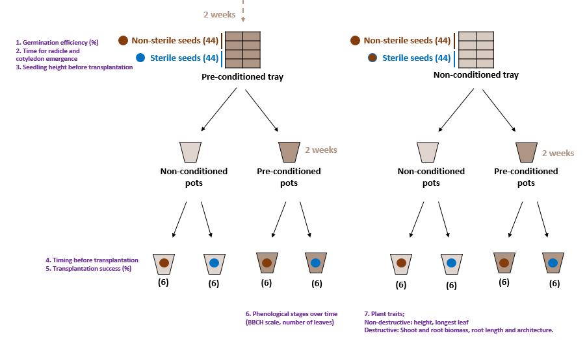

* **Evaluations**

1. Seedling emergence (survival)
2. Time until cotyledon emergence (days)
3. Leaves per seedling or seedling height before transplantation
4. Transplantation survival
5. Length x Width of 1st largest leaf (Peter’s measurement)
6. Time to phenological stage
7. Root and Shoot biomass after X weeks/days (if destructive, if not plants could be used for first MeJA pilots)

1. Volume and method of mechanical damage to be determined